LAB Logbook

Lab 1

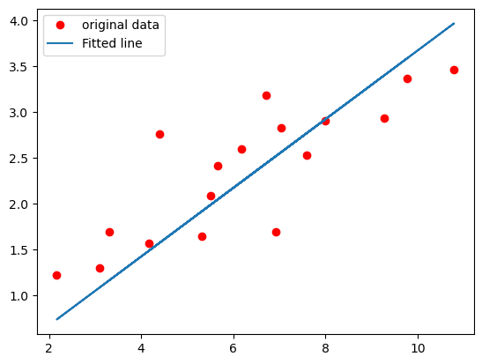

Lab 2

0.96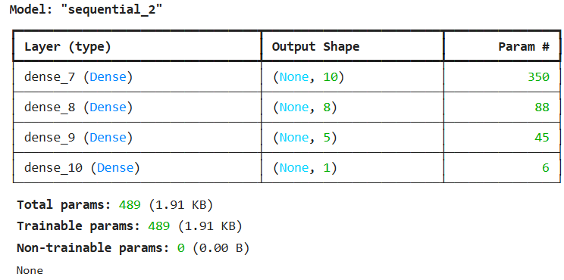

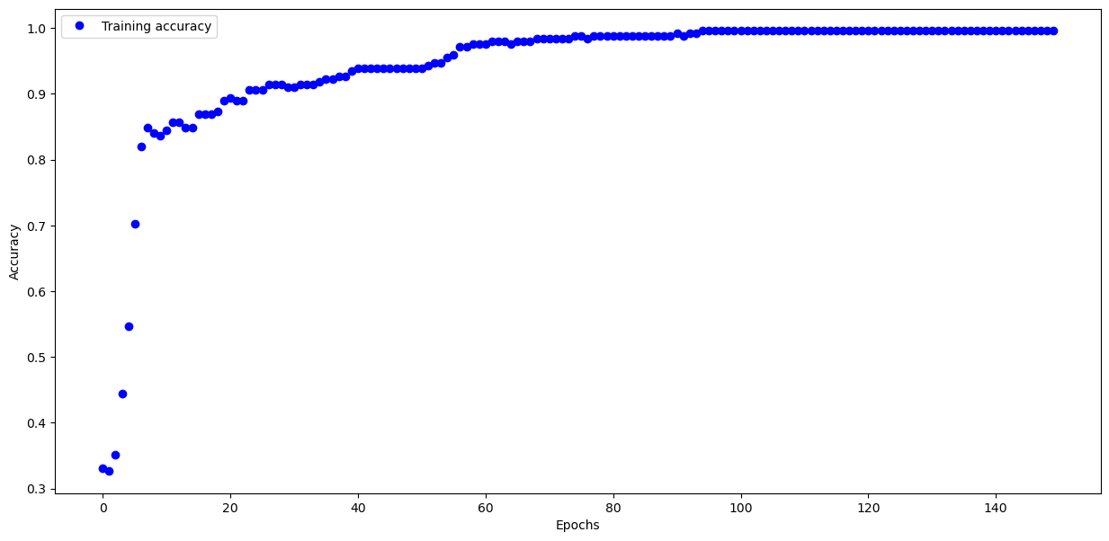

Lab 3

Test accuracy: 0.8855999708175659

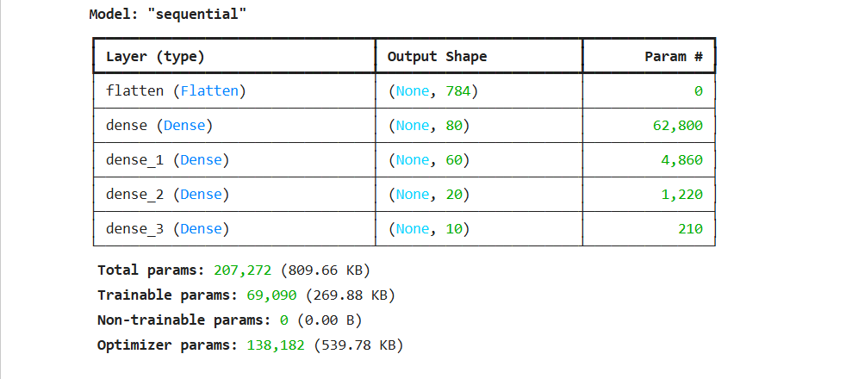

Lab 4

Model’s loss after every epoch

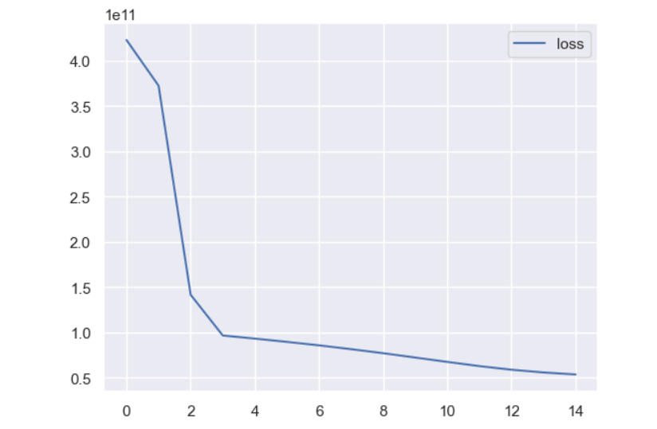

Model summary

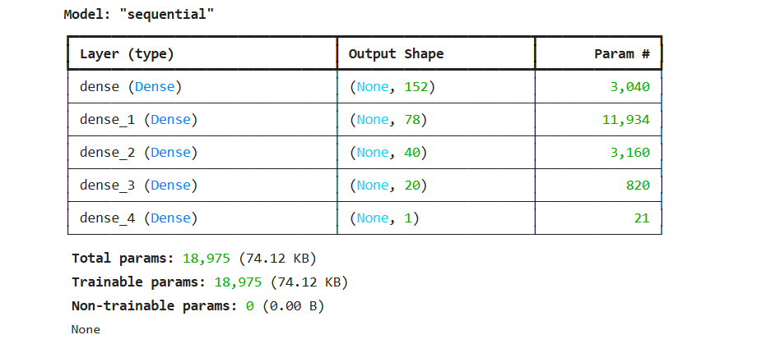

Lab 5

Lab 6

Lab 7

Lab 8

Lab 9

Lab 10

Lab 11

Lab 12